DSA LAB-10 Output Snippets
Task-1
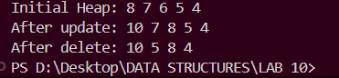
Task-2
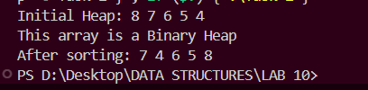
Task-3
